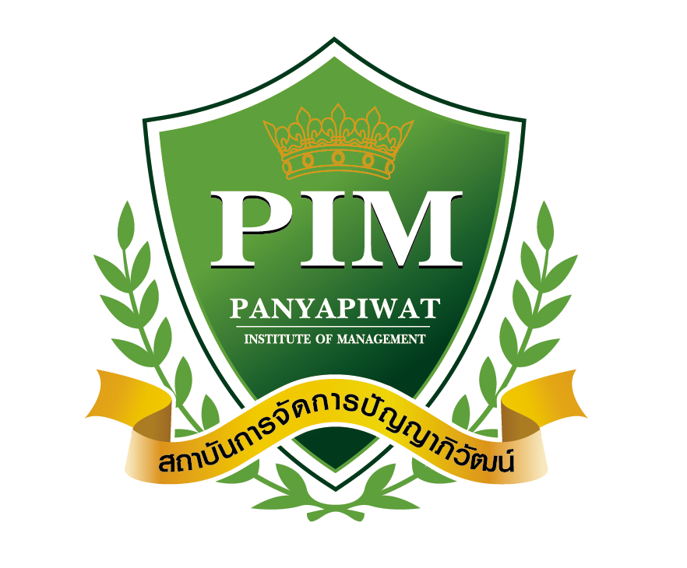
Consent Form for Publication
“The 16th National and the 12th International PIM Conference 2026”

1. Title of article....................................................................................................................................................
....................................................................................................................................................................................
2. Type of article
□ Research article □ Academic article
3. Author
□ Single author
□ Multiple authors
Author | First Name | Last Name | Affiliation | Country
Main author
1st Co-author
2nd Co-author
3rd Co-author
4th Co-author
5th Co-author
Note: In case of having more than 6 authors, the additional authors can be added below the remarks.
4. After the issuance of acceptance letter, the editorial board will not change or revise the name(s) and affiliation(s) of the author(s). Therefore, the author(s) who need the acceptance letter for graduation, scholarship or other purposes must check the requirement thoroughly before submitting the Consent Form for Publication.
5. The editorial board will reject the manuscript if over 30% plagiarism is detected.
6. The publication fee is non-refundable in all cases.
7. The author(s) certifies that:
7.1 The manuscript has never been published in any journals or any publications before, either in the country or overseas.
7.2 The manuscript must not be submitted to more than one journal/conference for simultaneous consideration, either in the country or overseas.
7.3 The author(s) will be held responsible for the infraction of all content, tables, and figures in the manuscript, in case any infringement of copyright is detected.
7.4The author(s) understands and agrees with the review policy and agree to make necessary revision of the manuscript according to comments/suggestions from experts.

8. If the manuscript does not adhere to the required format or if revisions are not submitted by the deadline, the publication may be canceled.
If the manuscript does not comply with the above-mentioned requirements, the editorial board reserves the right to withdraw it immediately without prior notice.

All authors agree to certify acknowledgement and give explicit consent to follow the above-mentioned conditions by signing below.
The main author

.........................................................
(............................................................)
............/............................../............
The 1st Co-author

.........................................................
(............................................................)
............/............................../............

The 2nd Co-author

.........................................................
(............................................................)
............/............................../............

The 3rd Co-author

.........................................................
(............................................................)
............/............................../............

The 4th Co-author

.........................................................
(............................................................)
............/............................../............

The 5th Co-author

.........................................................
(............................................................)
............/............................../............

Remarks: In case of having more than 6 authors, the additional authors can be added below along with their signatures.

