A LOW COST PROTOTYPE FOR AIR POLLUTION MONITORING

Sonam Tenzin¹, Theerapat Pobkrut², Satetha Siyang¹, Chayanin Khunarak¹, Teerayut Chaiyasit¹, Phuntsho Choden¹, Ugyen Dorji¹, Teerakiat Kerdcharoen^{2, 3,*}

¹Materials Science and Engineering Programme, Faculty of Science, Mahidol University, Bangkok 10400
²Department of Physics, Faculty of Science, Mahidol University, Bangkok 10400, Thailand
³NANOTEC Centre of Excellence, Mahidol University, National Nanotechnology Center, Bangkok, Thailand
* Corresponding author: teerakiat@yahoo.com

ABSTRACT
Air pollution due to explosive growth of industries and mega cities pose constant threat to human life. Till date, several commercial products to monitor air quality are available, but they are beyond the reach of average users due to heavy cost. The conventional analytical instruments are impractical due to bulky size, expensiveness and complicated operation. As a result, there are many designs of air quality monitoring prototypes reflected in the literature. However, many failed to talk about its cost and hardware and software requirements. Therefore, in this paper, a prototype (costing around $142.9) is designed to function as a low cost air pollution monitoring system. In addition, the process and requirements for designing a real-time, low cost and flexible air quality monitoring system is elaborated to assist beginners to refer, modify and implement the system. The prototype was tested near traffic area. The results have shown that the prototype can effectively describe the air pollution near the traffic zone.
Keywords: Air pollution, prototype, low cost, gas sensors
Introduction
Air pollution due to advancing industrialization, growing number of megacities and urban complexes possess a deadly threat for both biotic and abiotic factors, making it a subject of concern for researchers. Even though various types of air monitoring devices are available in market such as 1405-F, Dylos DC1100, AirCloud, PANDA, AirScope, CitySense, MICROSYS, Mobile Discovery Net, and aerQUAL (Zhuang, Lin, Yoo, & Xu, 2015; Ngoc, Lee, Gil, Jeong, & Lim, 2010: 288-293), these instruments are beyond the reach of average users due to heavy cost. Moreover, conventional analytical instruments are impractical due to its bulky size, noisy, expensive and complicated operation (Prashant Kumar and team members, 2016: 150-159) even though results are accurate. Another emerging technology called electronic nose is widely applied for monitoring air quality but most are general types of monitoring system having a broad-range of gas-sensing capabilities and applications. Nevertheless, there are more advantages in using a monitoring system fabricated based upon the specific application because the specific monitoring devices are much cheaper, flexible, and it can be sold to many clients (Wilson, 2013: 2295-2348).
Considering the aforementioned limitations, many real-time low cost air monitoring prototypes based on various technological modules are reported in the literature without detailing the cost, hardware and software requirements. Moreover, numerous practical and technical limitations associated with the system (Prashant Kumar and team members, 2016: 150-159), and different monitoring areas with varying micro-climate requiring numerous factors like objectives, pollutants, designs, techniques, and models (Zoroufchi Benis, Fatehifar, Shafiei, Keivani Nahr, & Purfarhadi, 2015: 779-793) need to be addressed and considered.
So, in this paper, a prototype is designed, implemented and evaluated by monitoring air quality and carbon monoxide level near the traffic zone. The system holds advantages like real-time, low cost (around $142.9) and do not require experienced personnel to design, install and operate. Most importantly, the process and requirements needed for designing low-cost air pollution monitoring system is elaborated in detail so that any beginners from all walks of life can refer, modify and implement the system.
literature Review
With the advancement of science and technology, there are many devices available in the market that monitors air quality. Most of these instruments are sensitive, robust, autonomous, reliable and flexible. However, they are expensive and beyond the reach of average users. One such device is Aeroqual series 500 portable gas sensor that monitors ozone and nitrogen dioxide in ambient air (Lin and team member, 2015: 111-116. The device is compact, lightweight, and can be operated with battery for 8 hours. Nevertheless, the device is very expensive costing $1270*. Other air monitoring devices such as BeGood’s BGFM – 08 and Qing Feng Kang Hua’s KHD – FA costing 1080 CNY and 2680 CNY respectively (Yang, Zhou, Zhang, & Chiang, 2015) are affordable but have limited gas detecting capability . The former one can detect formaldehyde, TVOC and humidity, and later one detects formaldehyde, temperature and humidity. Some other expensive air monitoring products commercially available include 1405 – F, Dylos DC1100, AirCloud and PANDA (Zhuang, Lin, Yoo, & Xu, 2015). In line with that, the air monitoring devices like CitySense, MICROSYS and Mobile Discovery Net (Ngoc, Lee, Gil, Jeong, & Lim, 2010: 288-293) are designed for professionals.
That is why, instead of using the commercially available devices, researchers design, implement, evaluate and report their own air monitoring prototype. However, there are limitations associated with the prototypes like failing to describe the cost and hardware and software requirements. For instance, Blit and team members, (2016: 138-142) and Wongchoosuk, Khunarak, Lutz, & Kerdcharoen, (2012) failed to mention the cost of the device, the type of the microcontroller used, and basic software requirements. The former one is used for determination of aroma and flavor quality of brewed black tea while the later one monitors indoor air quality. Similarly, Lecce, Daria, & Uva, (2011) successfully designed and implemented the wireless electronic nose system for indoor monitoring of air quality at different rooms of the hospital. While the paper described about hardware requirements, it failed to explain about the baseline responses.
Objective
To design and describe a low cost prototype for monitoring air pollution, in terms of hardware and software components.
Methods
- System Architecture
The main hardware components used for designing the system are described below.
  - Microcontroller and Data Logger
One of the most crucial hardware components for any monitoring system is the microcontroller that manages and performs systematic control of other devices in use. There are various types of microcontroller of which Arduino, available in the market at affordable price, is an open source platform microcontroller used for various prototyping and automatic projects (Jindarat & Wuttidittachotti, 2015: 284-288; Katyal, Yadav, & Pandey, 2016: 274-276). For this prototype, Arduino mega 2560 is used because of its multi-functionality.
The onboard memory of Arduino is not large enough to store volumes of data. Therefore, the data logger shield with SD card is used for storing data. The shield fits easily on top of the Arduino, thereby expanding its capabilities. The data logger shield comes with ZigBee connection feature for wireless communication, and RTC module to timestamp the monitoring.
  - Metal Oxide Gas Sensors
Metal oxide gas sensors being inexpensive, robust, lightweight, stable, long lasting, high sensitivity, and fast responsive (Fine and team members, 2010: 5469-5502), has been extensively used for environmental monitoring for detecting air quality. Therefore, in this prototype, MQ gas sensors are used for measuring gas pollutants. The sensors are circuited using six pin headed sensor holders and 10KΩ as pull-down resistor to avoid floating of data. The sensors are supplied with independent 5V DC source to keep the voltage requirement constant (Araki & Omata, 2013: 357-361), and the sensors are fixed in funnel shaped chamber for equal gas exposure. Along with the gas sensors, DHT22 is also used to record the temperature and humidity for setting the condition of monitoring.
  - Air Filter, Solenoid Valve, Relay, DC Fan and mini Air Pump
The air filter used for creating reference gas, is made by a layer of carbon and silica gel for absorbing VOCs and moisture respectively. The relay is an electrical switch that can be programed with Arduino to switch on and off the solenoid valve to pass sample and reference gas for sensing alternately.
A 12V DC fan is used for delivering air sample into the sensing chamber. The fan is fixed inside a funnel shaped chamber with a wire mesh as opening to prevent bigger dust particles from entering the system. The fan not only delivers the air sample but also helps to improve the sensitivity by accelerating the air circulation and functioning as cooling agent for the sensor chamber (Wang, Yuan, & Ling, October 2011). When the air filter is used, the micro axial fan alone is not enough to deliver the reference gas into the sensing chamber. Therefore, electrical pump is used to suck the gas through the filter to the sensing chamber.
  - ZigBee
The ZigBee protocols are widely used for wireless communication purposes because of its low cost, low power consumption, flexible network structure, large number of nodes, and high compatibility features (Kumar, Khan, Yadav, & Dubey, 2014: 51-59). For the purpose of transmitting the data wirelessly from the monitoring station to the base station, two numbers of ZigBee are used in the system. One of the ZigBee is interfaced with the Arduino by fixing on top of data logger with the help of ZigBee shield.
  - Software
The main software used is the freely downloadable open – source Arduino software (IDE) which comes in many updated versions, and the Arduino 1.6.5 is one among them. The Arduino 1.6.5 is installed in PC to write and upload various codes to Arduino mega 2560 microcontroller. The various codes written for the system includes (1) data logging code, (2) code for RTC module, (3) DHT22 code, and (4) analog read code for the sensors.
- Working Principle
Picture 1 is the schematic diagram showing the working of the system. The monitoring of gaseous pollutant is carried out in two processes. In the first event, when the system is switched on, the ambient air is allowed to flow through the air filter where some VOCs and moisture get absorbed. Then, in the second event, the valve is automatically closed allowing the ambient air to flow directly to the sensor chamber, and the process gets repeated over again. The code is written to read the gas concentrations in terms of voltage changes of the sensors. These changes are stored in micro SD card as raw data which can be opened in excel for analytical display of the gas concentration. At the same time, the data is transmitted to the receiver wirelessly with the help of ZigBee.
- System Installation
The prototype designed and described is tested by installing it at a station near traffic zone at Rama VI road, Faculty of Science, Phaya Thai campus, Mahidol University, Thailand as shown in picture 2. Before putting it to use, the system was trained by running it for a week to allow sensor adaptation to the target gas (Capelli, Sironi, & Del Rosso, 2014: 19979-20007). The data was recorded every second throughout the day for one month. However, for simplicity, the result is presented only for selected days of the month. The actual gas concentration can be calibrated using the methods described by Wongchoosuk, Khunarak, Lutz, & Kerdcharoen, (2012) and by Firdaus and team members, (2015). However, the calibration process is not the scope of this paper. At present, the prototype is validated by correlating the sensor response data to that of traffic density.
Results and Discussion
In order to validate the prototype, the experimental data is correlated to the traffic density. Picture 3 shows the level of CO gas and air quality in terms of voltage change for one of the selected day during the time of experiment. The voltage change is directly proportional to the gas concentration (Yang, Zhou, Qin, Zhang, & Chiang, July 2015). Picture 4 shows the google map of typical traffic condition on two important occasions during the selected day.
From the graph, it is clearly noticeable that the CO level is very high in the morning and in the early hours of night on the day of monitoring. This is because, typically the longer lasting time of high traffic density is found in the morning (7.40 – 10.50 am) and in the late evening (3.10 – 7.00 pm) respectively. Such type of result was also reported by Chaiwatpongsakorn, Lu, Keener, & Khang, (2014: 6246-6264). Picture 3 also indicates that the air quality near the traffic zone is influenced by the CO gas emission from the traffic. Like CO level, the air quality is poorer in the morning and in the late evening due to the high traffic density. Thus, the prototype is sensitive enough to monitor the CO gas and air quality level in correlation with the variation of the traffic density.
To validate furthermore, the CO level at 3.00 am (V_{3.00am}) for each day is set as the reference since the traffic density at this time is extremely low, and is compared with the CO level at other times (V_{other}) of the day for four consecutive days (Day 1 – Day 4) as shown in picture 5. As expected, the CO level for all the four days increases notably from 7.00 am till 4.00 pm compared with the reference time. On the other hand, the level of CO is found to decrease from 4.00 pm. Therefore, the result concludes that more emission of carbon monoxide gas occurs during the day, agreeing with the fact that the number of vehicles on the road increases during day time. The minor fluctuation trend of graph can be attributed to the sudden change of atmospheric conditions like temperature, humidity, wind speed and direction. Thus, it can be concluded that the prototype is able to determine CO gas level and the air quality depending on the density of vehicles on the road. However, in future, the prototype should be compared with the commercial air monitoring device specifically designed for road traffic application to determine its efficiency.

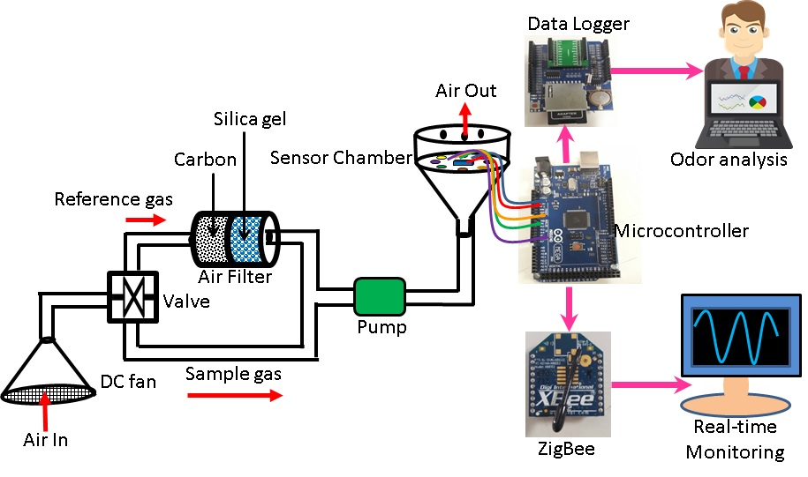  Picture 1: Schematic diagram of the system | 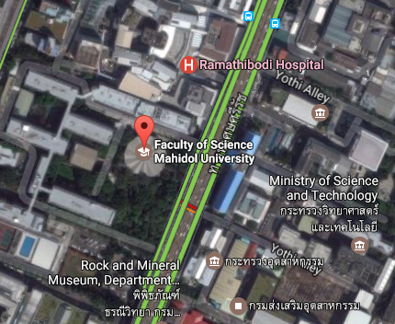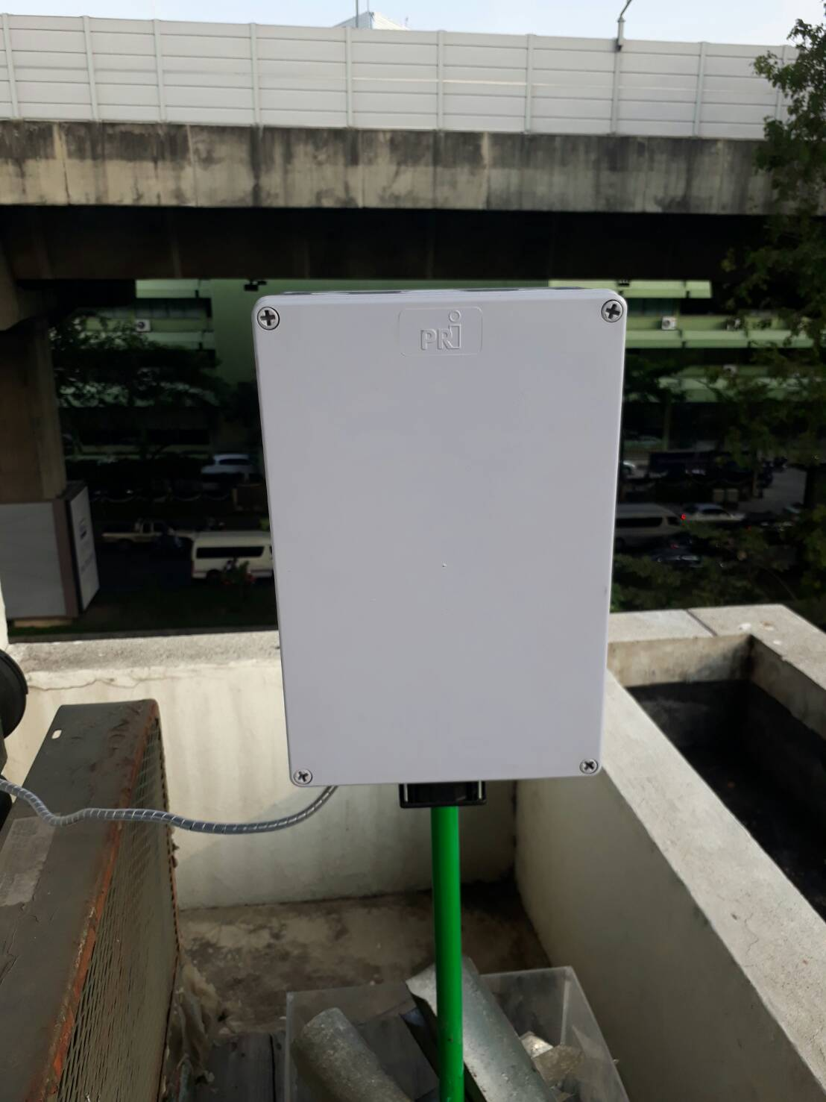Picture 2: Prototype installed near traffic zone
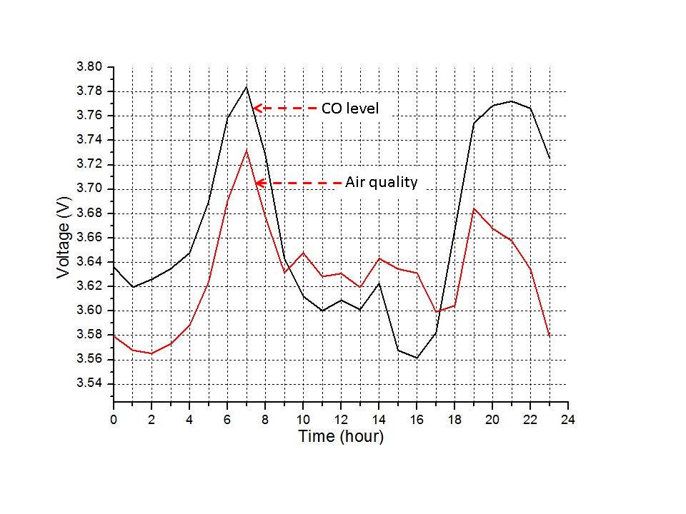  Picture 3: CO level and air quality |  | Picture 4: Typical traffic condition on the day of monitoring  Source: Google map
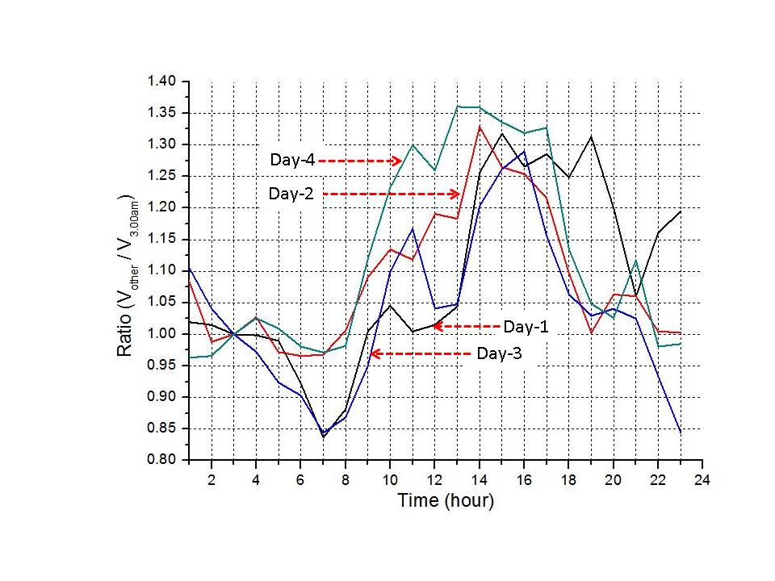
Picture 5: Graph showing CO level for four consecutive days at different times

Conclusion
In this work, the prototype for air pollution monitoring within the cost range of $142.9 is designed and described based on hardware and software components requirements. The system has the advantages of being low cost, real time, flexible and easy design methods and operation. The results have shown that the system is efficient enough to measure CO level and air quality near the highway. However, the prototype should be compared with the standard air monitoring devices to evaluate its performance. In future, we hope to analyze other gas pollutants and describe the calibration process for gas concentration in ppm level, and also to incorporate warning system to the prototype. In conclusion, we hope that the prototype elucidated in this work open up new avenues for beginners to refer while designing their own air monitoring system of interest.

References
Araki, H., & Omata, S. (2013). Measurement system for metal-oxide gas sensors, (3), 357–361.
Blit, I. W., Juwita, A. B., Suprijanto, & Nugraha. (2016). Prototype instruments for determination of aroma and flavor quality of brewed black tea. 4th International Conference on Instrumentation, Communications, Information Technology, and Biomedical Engineering (ICICI-BME), 138-142.
Capelli, L., Sironi, S., & Del Rosso, R. (2014). Electronic noses for environmental monitoring applications. Sensors (Basel), 14(11), 19979-20007.
Chaiwatpongsakorn, C., Lu, M., Keener, T. C., & Khang, S. J. (2014). The deployment of carbon monoxide wireless sensor network (CO-WSN) for ambient air monitoring, Int J Environ Res Public Health, 11(6), 6246-6264.
Fine, G. F., Cavanagh, L. M., Afonja, A., & Binions, R. (2010). Metal oxide semi-conductor gas sensors in environmental monitoring. Sensors, 10, 5469-5502.
Firdaus, Ahriman, N., Yulianto, A., & Kusriyanto, M. (2015). Wireless sensor network application for carbon monoxide monitoring, in proceedings for International Conference on Telecommunication Systems Services and Applications (TSSA).
Jindarat, S., & Wuttidittachotti, P. (2015). Smart Farm Monitoring Using Raspberry Pi and Arduino. International Conference on Computer, Communications, and Control Technology (I4CT), 284-288.
Katyal, A., Yadav, R., & Pandey, M. (2016). Wireless Arduino Based Weather Station. International Journal of Advanced Research in Computer and Communication Engineering, (5), 274-276.
Kumar, P., Skouloudis, A. N., Bell, M., Viana, M., Carotta, M. C., Biskos, G., & Morawska, L. (2016). Real-time sensors for indoor air monitoring and challenges ahead in deploying them to urban buildings. Sci Total Environ, 150-159.
Kumar, R., Khan, S., Yadav, M. C., & Dubey, S. K. (2014 ). Zigbee based weather monitoring system. International Journal of Advanced Technology in Engineering and Science, (2), 51-59.
Lecce, V. D., Daria, R., & Uva, J. (2011). A Wireless Electronic Nose for Emergency Indoor Monitoring. fifth international conference on sensors technologies and applications, 274-279.
Lin, C., Gillespie, J., Schuder, M. D., Duberstein, W., Beverland, I. J., & Heal, M. R. (2015). Evaluation and calibration of Aeroqual series 500 portable gas sensors for accurate measurement of ambient ozone and nitrogen dioxide, Atmospheric Environment, (100), 111-116.
Ngoc, T. Q., Lee, J., Gil, K. J., Jeong, K., & Lim, S. B. (2010). An ESB Based Micro-scale Urban Air Quality Monitoring System. Fifth International Conference on Networking, Architecture, and Storage, 288-293.
Wang, W., Yuan, Y., & Ling, Z. (October 2011). The Research and Implement of Air Quality Monitoring System Based on ZigBee. 7th International Conference on Wireless Communications, Networking and Mobile Computing.
Wilson, A. D. (2013). Diverse applications of electronic-nose technologies in agriculture and forestry. Sensors (Basel), 13(2), 2295-2348.
Wongchoosuk, C., Khunarak, C., Lutz, M., & Kerdcharoen, T. (August 2012). WiFi Electronic Nose for Indoor Air Monitoring. 9th International Conference on Electrical Engineering/Electronics, Computer, Telecommunications and Information Technology.
Yang, Q., Zhou, G., Qin, W., Zhang, B., & Chiang, P. Y. (July 2015). Air-Kare: A Wi-Fi Based, Multi-Sensor, Real-Time Indoor Air Quality Monitor, IEEE International Wireless Symposium (IWS 2015).
Zhuang, Y., Lin, F., Yoo, E.-H., & Xu, W. (June 2015). AirSense: A Portable Context-sensing Device for Personal Air Quality Monitoring, 2015 Workshop on Pervasive Wireless Healthcare, 17-22.
Zoroufchi Benis, K., Fatehifar, E., Shafiei, S., Keivani Nahr, F., & Purfarhadi, Y. (2015). Design of a sensitive air quality monitoring network using an integrated optimization approach. Stochastic Environmental Research and Risk Assessment, 30(3), 779-793.
* This cost is referenced from http://www.gas-sensing.com/aeroqual-series-500.html

